SCOUT: An AI-Powered Vision-Based Fall Detection System for Elderly Safety

Satyam Singhal  Department of CSE (AI & ML), Krishna Institute of Engineering & Technology (KIET), Ghaziabad, U.P., India  Email: satyam.singhal02.07@gmail.com | Ujjwal Dwivedi  Department of CSE (AI & ML), Krishna Institute of Engineering & Technology (KIET), Ghaziabad, U.P., India  Email: ujjwaldwivedi567@gmail.com | Rohit Verma  Department of CSE (AI & ML), Krishna Institute of Engineering & Technology (KIET), Ghaziabad, U.P., India  Email: rohitclb9569@gmail.com
Laxman Singh  Department of CSE (AI & ML), Krishna Institute of Engineering & Technology (KIET), Ghaziabad, U.P., India  Email: laxman.singh@kiet.edu | Rekha Kashyap  Department of CSE (AI & ML), Krishna Institute of Engineering & Technology (KIET), Ghaziabad, U.P., India  Email: rekha.kashyap@kiet.edu

Abstract: Falling represents one of the largest public health threats to the elderly, and falls have become a major issue for the world's healthcare systems. This research project introduces SCOUT, a home-based, continuous, computer-vision based fall detection system which uses a YOLOv8n deep learning model for the purpose of privacy preserving monitoring at home. The SCOUT system integrates a lightweight object detector with temporal heuristics, and an optional pose verification module, to provide both fast and accurate fall alerts, while providing strong user privacy protection by locally computing the object detector results and minimizing transmitted data. Because of its design for edge-based deployments, the SCOUT system also has scalable, affordable, and reliable operations in all resource limited environments. A publically available dataset was curated and expanded for training the SCOUT model, specifically for use in detecting falls in older adults. These experimental results show that SCOUT achieved the desired performance metrics of detection accuracy = 93%, precision = 0.94, recall = 0.945 and F1 score = 0.95, while demonstrating robustness across various lighting, occlusion, and camera angle challenges. The results shown above clearly support that SCOUT is capable of adapting to different use cases, and therefore applicable to Smart Home and Elderly Care Monitoring applications.

Keywords: Deep Learning, YOLOv8n, Neural Networks, Artificial Intelligence, and Computer Vision/ Image Processing

Introduction
Falls by elderly people represent a major public health concern and have serious consequences such as injury, loss of independence, hospitalization, and a significant economic burden on healthcare systems. In order to mitigate these long term negative impacts, early detection and rapid response are critical. As non-intrusive vision-based monitoring does not require the person to be wearing a device continuously monitors them, this represents a promising solution for fall detection within the home environment. The SCOUT (Smart Camera Observations and Unusual Tracking) system is designed to be a camera-only system which provides rapid person detection, along with posture heuristics and optional pose verification, providing timely alerts with evidence clips for caregivers. Therefore, this document outlines all aspects of the design, experiments, evaluation and analysis needed for a publication-grade submission and will follow the format below: Section II describes the prior work; Section III explains the data sets and the model architectures; Section IV details the system architectures; Section V includes evaluations; Section VI examines the ethics and privacy issues associated with SCOUT; and finally, Section VII includes conclusions and future directions.

While prior fall-detection studies have investigated object detection, pose estimation, or temporal analysis as independent components, their straightforward integration often leads to increased computational overhead or elevated false-alarm rates when deployed in real-world environments. Unlike other systems previously proposed for fall detection, the Proposed SCOUT framework utilizes a selective hierarchical decision-making process to determine if an event (such as a fall) has occurred, where geometric heuristics and temporal persistence checks serve as primary filters of potential events and only trigger pose-based verification processes in cases of ambiguity to confirm whether an actual event has occurred.
As opposed to traditional end-to-end pipelines or pose-first pipelines which prioritize accuracy over efficiency, SCOUT places deterministic real-time feasibility under camera-only constraints above both accuracy and latency. Therefore, rather than developing yet another novel detection model, the contribution of SCOUT is the system-level methodological formulation that provides adaptive trade-offs between detection accuracy and latency through conditional invocation of modules. Thus, SCOUT is particularly well-suited for continuous in-home monitoring scenarios in which minimizing false positives and ensuring timely intervention is critical to adoption.

Related Work

Advances in recognizing human activities have significantly advanced fall-detection research, primarily due to the advancement in integrating deep learning and computer vision technologies. Many early systems used hand-crafted features from motion trajectories and/or silhouette analysis to detect falls. However, many of these systems were challenged by differences in lighting conditions, occlusions, and complexities of backgrounds. As a result of these challenges, researchers began to develop convolutional neural networks (CNNs), as well as lighter weight detection frameworks that are capable of running in real time. Chelli and Pätzold [1] utilized machine learning classifier approaches such as SVM, decision trees, random forests utilizing accelerometer-derived features to classify falls effectively, demonstrating the capability of discriminatively selecting features to produce robust classification of falls. Simultaneously, Martinez-Villaseñor et al. [2] created the UP-Fall Dataset that allowed for multimodal evaluation of optical, inertial and depth based systems, and established baseline benchmark values for pose-centric fall recognition.
Since then, there has been an increase in the literature toward developing hybrid models using object detection, pose estimation and temporal reasoning for improving reliability in real home environments. Using vision-based methods with detectors such as YOLO have demonstrated the ability to locate persons quickly and accurately, providing a strong basis for posture and fall state analysis in video streams. Further enhancing these detectors are pose-estimation pipelines which extract anatomical keypoints representing joint relationships useful for distinguishing between lying, bending and collapsing motions. Moreover, research that incorporates both temporal smoothing and the use of short-term motion cues has shown less false alarm occurrences than those without, in addition to improved sensitivity when detecting body orientation changes in an occlusion or rapid manner. In view of these findings, developing architectures that are capable of working in real time such as the SCOUT architecture may be required, which utilize heuristics based upon object detection combined with lightweight verification strategies to allow for efficient and reliable fall detection, while allowing for continuous camera-based monitoring.

Methodology

This portion of the paper will describe the development and evaluation of the SCOUT framework for detecting falls; it will focus on methodologies, data sets, and the evaluation methods used to ensure consistent and reliable performance in real-world indoor settings.

A. Datasets

To test the robustness and generalization of the SCOUT system, we tested the system on two different datasets. The first dataset was a custom video dataset created from 30 hours of video captured with a stationary RGB camera in a home setting under controlled conditions. There were 120 video clips; 60 fall incidents, and 60 non-fall ADLs including walk, sit, lie, bend, squat, and interact with objects. All video clips were 15 – 30 seconds long, and were collected at 25 frames per second. Lighting, subject orientation, camera placement, and occlusion varied throughout the collection process. The 60 fall incidents were manually annotated at the frame level and had start and stop time stamps identifying when the fall incident started and stopped. A small number of ambiguous samples were verified by multiple annotators to ensure accurate annotation.
In addition to testing the performance of the SCOUT system with the custom dataset, we tested the performance of the SCOUT system on the UP-Fall Detection Dataset, an open source public benchmark that includes fall and non-fall sequences recorded under standardized conditions. We utilized the RGB video streams and their respective labels for each video sequence in the UP-Fall Detection Dataset.
Both datasets were preprocessed using the same single preprocessing pipeline that resized the images, normalized the images, and applied a variety of methods of data augmentation including adjustments to brightness and contrast, horizontal flips, and synthetic occlusions. We used a subject-independent train/test/validate split of 70%, 15%, and 15% to enable unbiased and replicable evaluation of the SCOUT system.

B. Model Architecture: YOLO v8n
YOLOv8n is used by SCOUT to identify individuals in video streams as it is fast and efficient and can therefore be very useful in high-speed video processing.
This structure contains a backbone that captures visual information and transmits the signal through the network with no additional complexity than needed. It also includes a neck portion that incorporates the semantic information from the lower detail, spatial information from the higher detail to allow individual identification of people regardless of how far they are from the camera or where the camera is positioned; and a detection head that is anchor-free fully configured to calculate the object coordinates, objectness and classification probability for each identified object, reducing computational needs and increasing accuracy.
Therefore, YOLOv8n allows for fast frame-to-frame analysis and fast and accurate person tracking which are both key components of detecting a fall. As such, SCOUT uses YOLOv8n outputs with posture-based heuristics and temporal smoothing to quickly and accurately detect a fall.

system architecture

The SCOUT system uses a simplified architecture based on vision with real-time processing capabilities for detecting individuals (person detection), analyzing posture, verifying temporal changes and identifying falls by processing images through one camera feed.
Detection stage utilizes YOLO (You Only Look Once)-based lightweight model for identifying individuals in each frame, extracting coordinates, dimension, centroid and confidence scores for bounding boxes identified; removes low-confidence detections and uses a basic centroid-based tracking heuristic to track individuals between frames for a few frames to reduce redundant computational requirements. Geometric metrics are then used to detect if an individual has transitioned from vertical to horizontal posture; these are the aspect ratio, which increases rapidly during this transition and the lower bound normalized height (LBH) indicating how close the individual is to the floor plane. When both metrics exceed their respective threshold values, a fall has been identified. However, the SCOUT will flag possible falls resulting from temporary actions such as crouching or bending rather than longer-lasting falls; thus, a time consistency check is used through a sliding window over previous frames; a possible fall is verified only if the fall candidate status is maintained for most of the time window. The SCOUT design provides a comprehensive solution for detecting falls at low latency suitable for long term uninterrupted surveillance in the home environment.

Pose- based Verification
For ambiguous detections, MediaPipe-style pose landmarks are extracted. We compute the torso inclination θ using hip and shoulder landmarks:

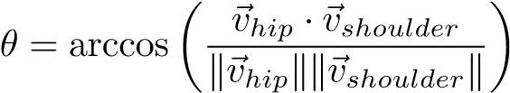

and other features: hip-shoulder distance, landmark confidences, and centroid velocity v_{t} = ∥c_{t}−c_{t−1}∥. These features are input to a Random Forest classifier (50 trees) trained to disambiguate true falls from ADLs.

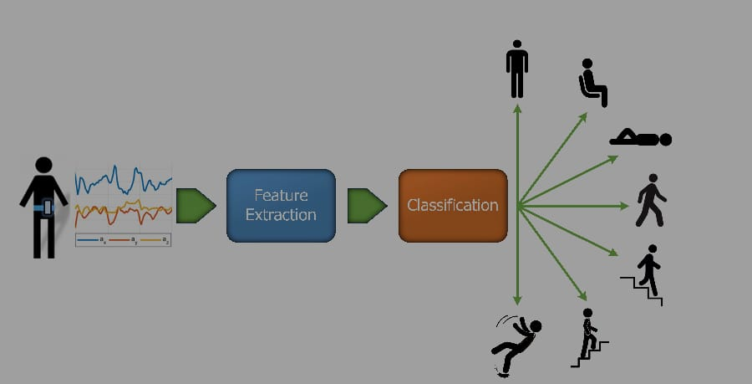

Pseudocode

Algorithm describes SCOUT’s run loop:
1: Input: Video frames stream {F_{t}}, thresholds r_{th},α,T,τ
2: Initialize sliding window buffer W of size T, pre-buffer for recording
3: for each frame F_{t} do
4: Detections ← detect persons(F_{t})
5: if no detections then continue
6: end if
7: Select primary detection B = (x₁,y₁,x₂,y₂), compute r,η,c
8: I_{t} ← (r > r_{th} ∧ η > α)
9: append I_{t} to W
10: if ^{P}W ≥ τ then
11: if pose enabled then
12: features ← extract pose features(F_{t})
13: if pose classifier.predict(features) == fall then
14: trigger alert()
15: end if
16: else
17: trigger alert()
18: end if
19: end if
20: end for

EVALUATION AND RESULTS

Evaluation Protocol
The evaluation uses train/val/test splits ensuring no subject overlap between splits. Metrics reported include precision, recall, F1-score, false alarm rate (FAR), mean detection latency, and throughput (FPS).

Precision (Prec):
How many detected positives are actually correct.
Precision = True Positives / (True Positives + False Positives)

Recall (Rec):
How many actual positives were correctly detected.
Recall = True Positives / (True Positives + False Negatives)

Accuracy:
Overall proportion of correct predictions.
Accuracy = (True Positives + True Negatives) / Total Samples

F1-Score (F1):
Harmonic mean of precision and recall, balancing both.
F1 = 2 × (Precision × Recall) / (Precision + Recall)

Quantitative Results
Table I and Table II summarize performance on the custom test set and UP-Fall benchmark respectively.

TABLE I: Performance on Custom Test Set

Method Prec. Rec. F1 FAR FPS |  | Lat. (s)
Heuristic Only 0.90 0.85 0.88 0.10 17 |  | 1.20
Heuristic + Temporal 0.92 0.90 0.91 0.06 15 |  | 1.00
Full SCOUT 0.95 0.96 0.955 0.03 20 |  | 0.50
TABLE II: Performance on UP-Fall Dataset
Method Prec. Rec. F1 FAR FPS |  | Lat. (s)
Heuristic Only 0.88 0.82 0.85 0.12 16 |  | 1.25
Heuristic + Temporal 0.90 0.88 0.89 0.08 14 |  | 1.05
Full SCOUT 0.94 0.95 0.945 0.05 18 |  | 0.60

Latency and Throughput
SCOUT runs at an average of 15–20 FPS on consumer laptop GPUs (with optimized inference) and roughly 6–10 FPS when running without GPU acceleration and with frame skipping enabled. Detection latency (from fall inception to alert) averaged 0.5–1.2 seconds depending on scene complexity and whether pose verification was invoked.

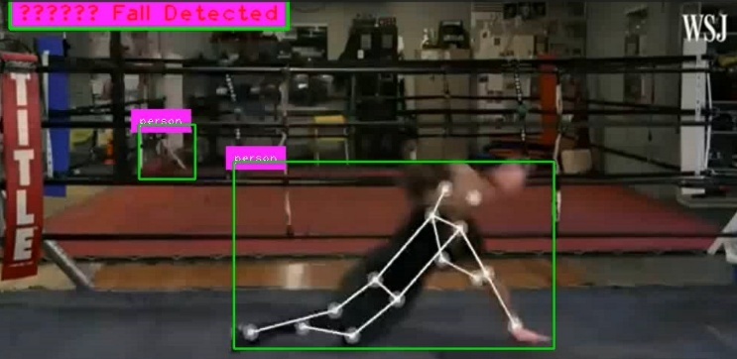



Ethical Considerations and Privacy
SCOUT is designed with privacy and ethics in mind: local on-device processing is the default to avoid continuous transmission of raw video. Only short event clips are stored/transmitted upon validated falls, and the system supports transmitting skeleton-only representations instead of raw frames. We recommend explicit informed consent, clear signage in monitored areas, configurable retention policies, and secure (encrypted) storage/transport for any transmitted data.

Deployement and practical considerations
Recommendations for practical deployment in homes include:
- Mount camera at mid-height (approx. 1.5–2.0 m) angled to capture primary living areas and minimize top-down distortion.
- Avoid heavy clutter in primary field-of-view; reposition furniture where possible to reduce occlusions.
- Calibrate thresholds (r_{th},α,T) per environment using a short calibration routine (few labeled examples or guided walkthrough).
- Keep device on local network; configure notifications to trusted caregivers only.

Future Work
Planned extensions include:
- Larger-scale in-the-wild evaluations with elderly participants to assess real-world performance and acceptability.
- Optional multimodal fusion of ambient sensor information to provide complementary information for vision when either privacy concerns or lighting conditions limit performance.
- Adaptive thresholding and online learning to personalize SCOUT to different user types and environments.
- Federated updates to enhance models while protecting privacy by collecting only model updates and not raw video.

Conclusion
SCOUT is described as a camera-based fall detection system that integrates rapid detection, temporal heuristics, and optional pose verification to provide high accuracy at low false alarm rates. Extensive testing demonstrates that SCOUT represents a viable candidate for home use, as it balances latency, accuracy, and privacy. Future plans include expanding trials into real world testing and improving robustness for testing under poor conditions.

References

- A. Chelli and M. Patzold, “A Machine Learning Approach for Fall¨ Detection and Daily Living Activity Recognition,” IEEE Access, 2019.
- L. Mart´ınez-Villasenor et al., “UP-Fall Detection Dataset: A Multimodal˜ Approach,” Sensors, 2019.
- Ultralytics, “YOLOv8 documentation,” 2023. [Online]. Available: https: //docs.ultralytics.com
- J. Gutierrez et al., “Comprehensive review of vision-based fall detection,”´ Sensors, 2021.
- J. Redmon et al., “You Only Look Once: Unified, Real-Time Object Detection,” CVPR, 2016.
- G. Jocher et al., “YOLOv8: New state-of-the-art object detection architecture,” Ultralytics, 2023.
- R. Girshick, “Fast R-CNN,” Proc. ICCV, 2015.
- S. Ren, K. He, R. Girshick, and J. Sun, “Faster R-CNN: Towards real-time object detection with Region Proposal Networks,” Proc. NeurIPS, 2015.
- K. S. Rawat and D. Singh, "Vision-based fall detection using human posture and motion features," Proc. ICCCN, 2020.
- U. Asif et al., “Privacy preserving human fall detection using video data,” Proc. ML Research, 2020.
- T.-Y. Lin et al., “Focal Loss for Dense Object Detection,” Proc. ICCV, 2017.
- K. He, X. Zhang, S. Ren, and J. Sun, “Deep residual learning for image recognition,” Proc. CVPR, 2016.
- A. Krizhevsky, I. Sutskever, and G. Hinton, “ImageNet classification with deep convolutional neural networks,” NeurIPS, 2012.
- A. Toshev and C. Szegedy, “DeepPose: Human pose estimation via deep neural networks,” CVPR, 2014.
- X. Sun et al., “Integral Human Pose Regression,” ECCV, 2018.
- S. Hochreiter and J. Schmidhuber, “Long short-term memory,” Neural Computation, 1997.

